

Functional Requirements Document (FRD)
  - Banner Wholesale Grocers – Tax Customization

Copyright© 2018, Oracle and/or its affiliates. All rights reserved.
Any reproduction or distribution of any part of this document without the prior written permission of Oracle + NetSuite is strictly prohibited.
The information included in this document is confidential and proprietary information of Oracle + NetSuite.
Version: August 8, 2018

Oracle + NetSuite
2955 Campus Drive, Suite 100
San Mateo, CA. 99403-2511

Project Information
Implementation Name | J876842 Banner Wholesale Grocers | Change Order 002
Customer Name (Number) | 4679428 Banner Wholesale Grocers
Job Name (Number) | J876842
Document Owner | Myr Villa
Functional Consultant | Myr Villa
Technical Consultant | Ilan Daniele

Document Version History
Rev | Date | Author(s) | Change Summary
0.1 | 09/22/2022 | Myr Villa | Initial draft
0.2 | 09/23/2022 | Ilan Daniele
0.3 | 09/27/2022 | Kevin Cristobal
0.4 | 09/27/2022 | Ilan Daniele | Final touches

Table of Contents
1 Introduction 4
2 Business Requirements 4
3 Solution Overview 4
4 Assumptions 7
5 Sample Test cases 7
6 Acceptance 9

Introduction
Banner Wholesale Grocers is a family-owned business to provide over 4,000 products which preferred destination for grocery stores, supermarket, retail shops, restaurants, and other wholesale companies.
Banner Wholesale seeks additional functionality on their SuiteCommerce webstore. They require a customization to compute tax rate amounts depending on different items, on the checkout process, which will show the total amount of tax applied.

Business Requirements
The document will cover the following customization:
Create a customization for SuiteCommerce Standard site that will display a warning message on the checkout section, and modify checkout section in order to apply certain taxes depending on whether the product is subject to the Chicago Water Tax and if the customer is marked as water taxable or not.
The product will be subject to a Chicago Water Tax based on the Tax Group of the item, which is set by Banner Wholesale Grocers
The customer will be subject to the Chicago Water Tax depending on a checkbox on its record set by Banners Wholesale Grocers; if checked, the customer is exempt from the Chicago Water Tax; if unchecked, the customer will be subject to the Chicago Water Tax.
Before submitting this order, these taxes should be applied into the sales order, and there will be taxes added from an ERP Script being run after submit.

Solution Overview
This solution will cover the following conditions that Banner Wholesale Grocers have in determining that a web order is eligible to compute tax rate amount for different items. It will follow next steps in order to get it:
- A taxable customer logs into webstore to purchase products:
We will look onto the customer record to see the checkbox “customer tax exempt” marked or not, depending if the customer should pay for the tax or not; if unchecked, the customer will be subject to the Chicago Water Tax.
- Customer selects a plastic water bottle item:
A Plastic Water Bottle item is defined by the Tax Group Field (Field ID: custitem_nscs_tax_code) on the Item Record. The field is populated as “IL_Cook_Chicago - BOTTLED WATER”.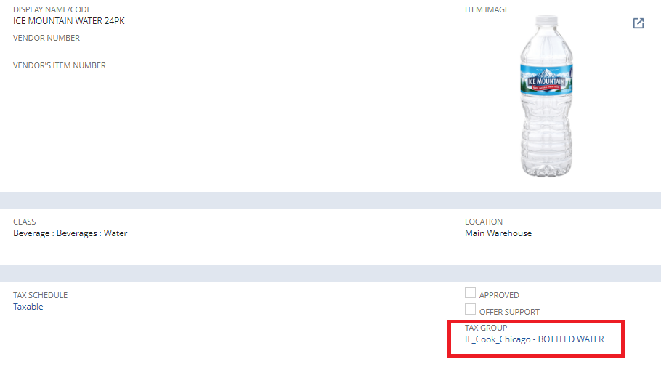
An item that is not classified as Plastic Water Bottle is defined by the Tax Group Field (Field ID: custitem_nscs_tax_code) on the Item Record. The field must not be populated as “IL_Cook_Chicago - BOTTLED WATER”.
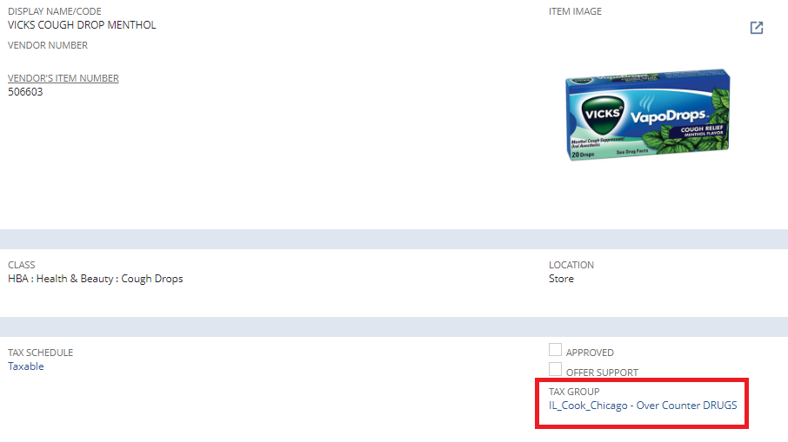
When the user views the Item in the Product Details Page, an information about the water tax rate amount to be added upon checkout is defined in the Description section: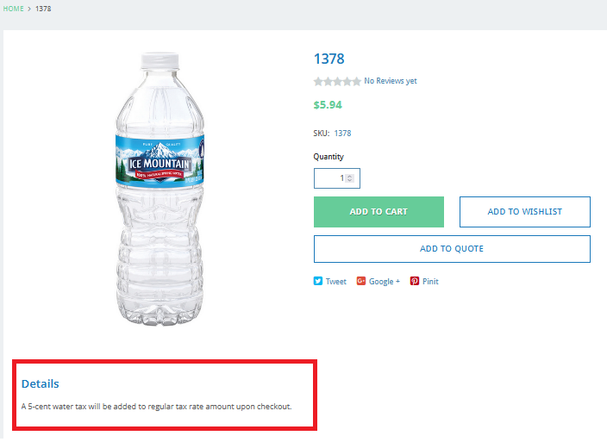
3. Taxable Customer adds plastic water bottle to the cart
Then in checkout summary, there should be a new line added that says “Water tax” and it’s amount, to show the water tax rate amount when the item is plastic water bottle. Which can be similar to this:
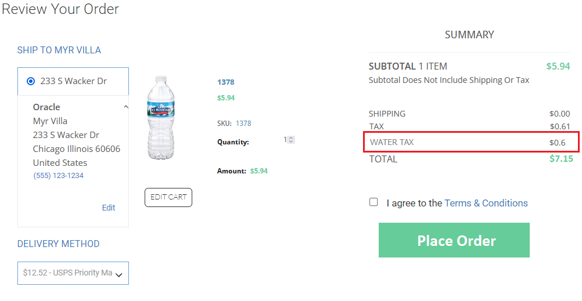
The “Water tax” amount will be obtained via item record, from the field Chicago Water Tax

4. Taxable Customer adds another item with water tax to the card
In checkout summary, the water tax amount should recalculate, adding the water tax amount of the new item.
5. Customer places order upon completion of checkout and water bottle tax rate amount computation should be added to the tax native tax amount in Sales Order. The Sales Order will have a new item line called “Chicago Water Tax” that will contain the total Chicago Water Tax amount for a Sales Order
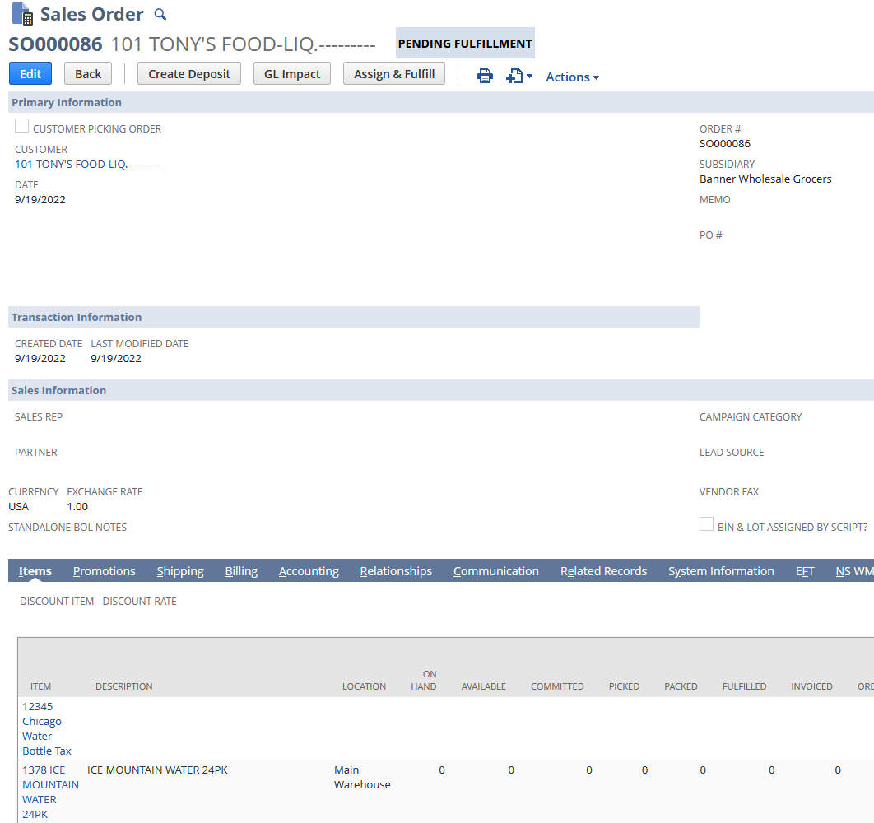

Assumptions
- Chicago Water Tax will be handled by our customization, and Banner Wholesale Grocers will fill up the necessary data.
- Customer will update the description of items subject to the Chicago Water Tax.
- Regular and non-regular item taxes will be handled by NetSuite. Non-regular and regular items follow the standard tax amount computation in the NetSuite.
- All customers are classified either water tax exempt or not. If customer is in Chicago, Banner Wholesale Grocers is in charge of setting it’s tax exempt checkbox to false. Also, if the customer moves, Banner is responsible for updating so. When the customer changes the shipping information (e.g., Chicago to California), Banner Wholesale Team needs to manually handle the issuing credit for water tax they should not be paying for. Conversely, if a customer moves to Chicago, Banner Wholesale team will manually handle issuing water tax to that customer.

Sample Test cases

Tests for Banner Wholesale Grocers Users
TEST 1: Sales order has items subject to Water Tax, Customer is not water tax exempt.
- Test item has Tax Group of “IL_Cook_Chicago - BOTTLED WATER” on the Item Record.
- The “Water Tax Exempt” checkbox should be unchecked on the Customer Record.
- Login to webstore and search for the item. An information about the added water tax rate amount is defined under Description section of the Product Details Page.
- Add item to cart and proceed to checkout.
- Verify the Water Tax amount should appear on the Summary section
- Submit order and check the tax computation in the Sales Order.

TEST 2: Sales order has items subject to Water Tax, Customer is water tax exempt.
- Test item has Tax Group of “IL_Cook_Chicago - BOTTLED WATER” on the Item Record.
- The “Water Tax Exempt” checkbox should be checked in the Customer Record.
- Login to webstore and search for the item. An information about the added water tax rate amount is defined under Description section of the Product Details Page.
- Add item to the cart and proceed to checkout.
- Submit order and check the tax amount value in the Sales Order.

TEST 3: Sales order has no items subject to Water Tax.
- Test item is not classified as Tax Group of “IL_Cook_Chicago - BOTTLED WATER” on the Item Record.
- Login to webstore and search for the item. Add item to the cart and proceed to checkout.
- Submit order and check the tax amount value in Sales Order.

Acceptance
Oracle + NetSuite Professional Services and Customer are in agreement that the information documented above is accurate and representative of the customer’s business needs. This document will act as the basis for all subsequent implementation activities.
Delivery Date:
Document Version:
- v0.1 – Initial Draft
- v0.2 – Made change to test cases, assumptions
- v0.3 – Added a step involving the creating of a Sales Order in ERP; Water tax is now referred to as “Chicago Water Tax”; Customers subject to water tax now determined based on a checkbox (Water Tax exempt) in the Customer record
- v0.4 - Added approach to retrieve Chicago Water Tax amount
- v0.5 – Updated behavior of Water Tax Exempt checkbox; Unchecked = subject to Chicago Water Tax, checked = exempt

Oracle + NetSuite Acceptance
Action | Name | Title | Signature | Date
Accepted By | Myr Villa | Functional Consultant
Accepted By | Ilan Daniele | Technical Consultant

Customer Acceptance
Action | Name | Title | Signature | Date
Accepted By | Jeff Harrigan | Project Manager

